1. |
   1. For this pooled OLS regression, we are going to use three dependent variables vio (violent crime rate per 100,000), rob (robbery rate per 100,000), and mur (murder rate per 100,000). We will use the following regression formulas. Results can be seen in Table 1.
      1. vioit = bo + b1 shallit + b2 yearit + b3 avgincit + b4 pm1029it + b5 density + b6 pop + eit
      2. robit = bo + b1 shallit + b2 yearit + b3 avgincit + b4 pm1029it + b5 density + b6 pop + eit
      3. murit = bo + b1 shallit + b2 yearit + b3 avgincit + b4 pm1029it + b5 density + b6 pop + eit
   2. Now using the same data but preforming a random-effect regression we use the following formulas. Results can be seen in Table 2.
      1. vioit = bo + b1 shallit + b2 yearit + b3 avgincit + b4 pm1029it + b5 density + b6 pop + ai + eit
      2. robit = bo + b1 shallit + b2 yearit + b3 avgincit + b4 pm1029it + b5 density + b6 pop + ai + eit
      3. murit = bo + b1 shallit + b2 yearit + b3 avgincit + b4 pm1029it + b5 density + b6 pop + ai + eit
   3. Now using the same data but preforming a fixed-effect regression we use the following formulas. Results can be seen in Table 3
      1. vioit = bo + b1 shallit + b2 yearit + b3 avgincit + b4 pm1029it + b5 density + b6 pop + ai + eit
      2. robit = bo + b1 shallit + b2 yearit + b3 avgincit + b4 pm1029it + b5 density + b6 pop + ai + eit
      3. murit = bo + b1 shallit + b2 yearit + b3 avgincit + b4 pm1029it + b5 density + b6 pop + ai + eit
   4. For regressions a, we find a large effect and a high significance for most of our regressors especially for murder rate. This contrasts with our random regression which have no statistical significance and our fixed effect regression which shows very little statistical significance. Based on these results it is likely our pooled OLS regression and our random effect regression gives us inconsistent estimators.
   5. The results for our Hausman test can be seen in Table 4, Table 5, and Table 6. Based on these results all our tests reject the null hypothesis of being consistent. Based on this all our results are inconsistent. The requirements for using the Hausman test is that the data be homoscedastic and not be serially correlated.
2. |
   1. Our three regression results from the following equations can be seen in Table 7
      1. Fatalityrateit = = bo + b1 sb_usageit + b2 drinkage21it + b3 drinkage21it * speed70it + ai + eit
      2. Fatalityrateit = = bo + b1 sb_usageit + b2 drinkage21it + b3 drinkage21it * speed70it + ai + λt + eit
      3. Fatalityrateit = = bo + b1 sb_usageit + b2 drinkage21it + b3 drinkage21it * speed70it + ai + λt + ηit + eit
   2. Using the comparison seen in Table 8 and our previous results we can conclude that speed limit has no significant effect on DUI. In our results in part A we see that drinking age * Speed 70 has no statistical significance. Based on these two results we conclude that lowering the speed limit has no significant effect on DUI.
   3. Results can be seen in Table 9
      1. ΔFatalityrateit = = bo + b1 Δsb_usageit + b2 Δdrinkage21it + b3 Δ(drinkage21it * speed70it) + eit
      2. ΔFatalityrateit = = bo + b1 Δsb_usageit + b2 Δdrinkage21it + b3 Δ(drinkage21it * speed70it) + Δλt + eit
      3. ΔFatalityrateit = = bo + b1 Δsb_usageit + b2 Δdrinkage21it + b3 Δ(drinkage21it * speed70it) + Δλt + ηi + eit
   4. To test for strict exogeneity we compare our coefficients from our FE and FD regressions. For our first regression given that they are significantly different from each other and cannot be explained by sampling variability we conclude that strict exogeneity is violated. For our model two and three our coefficients are not as significant different meaning there is possibility for strict exogeneity to hold but given that they are different we cannot make any definite conclusions without further analysis.

Appendix:

Table 1:

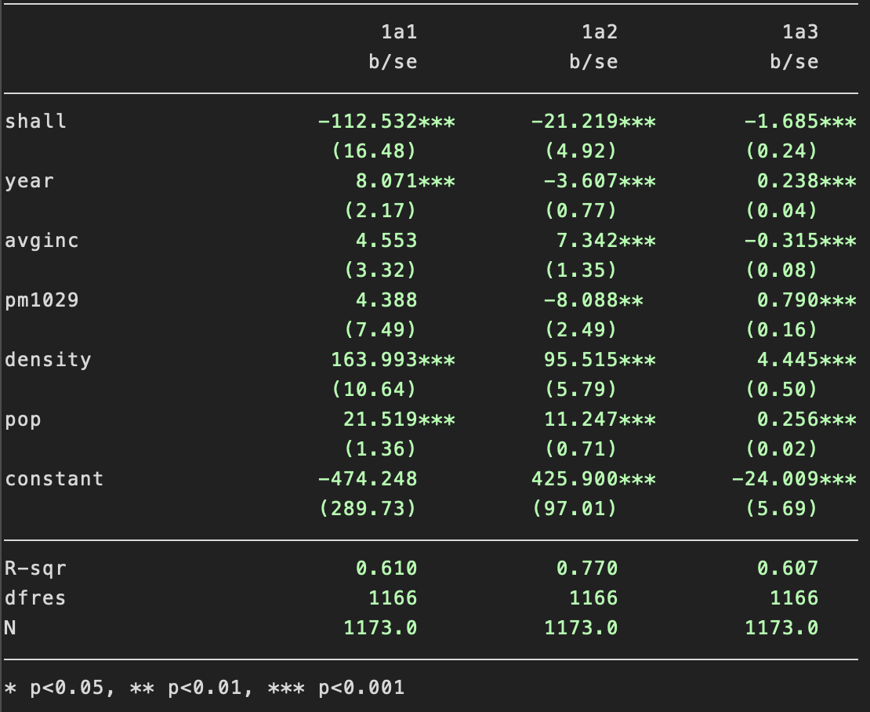

Table 2:

Table 3:

Table 4:

Table 5:

Table 6:

Table 7:

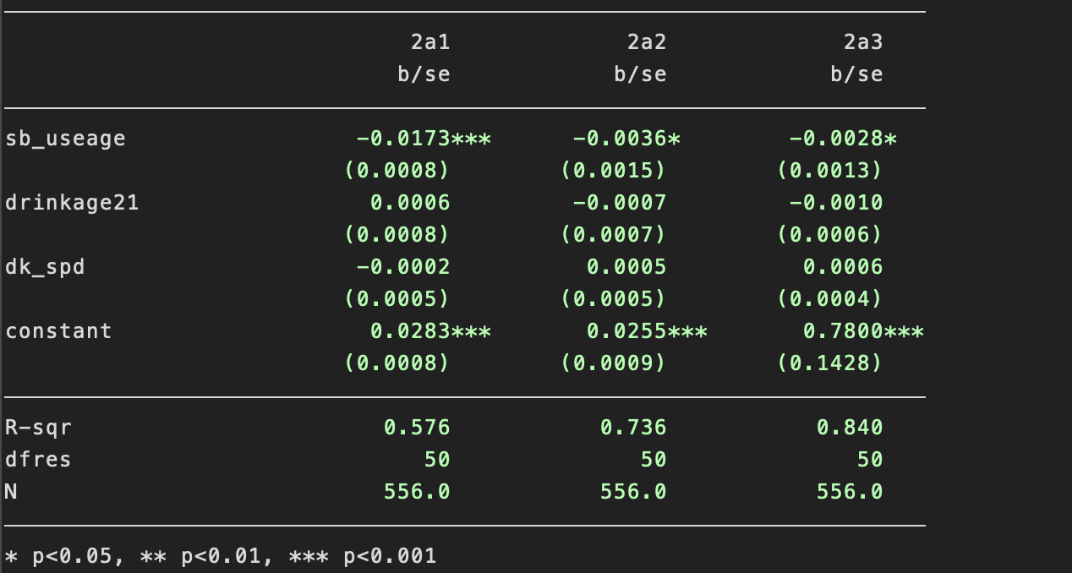

Table 8:

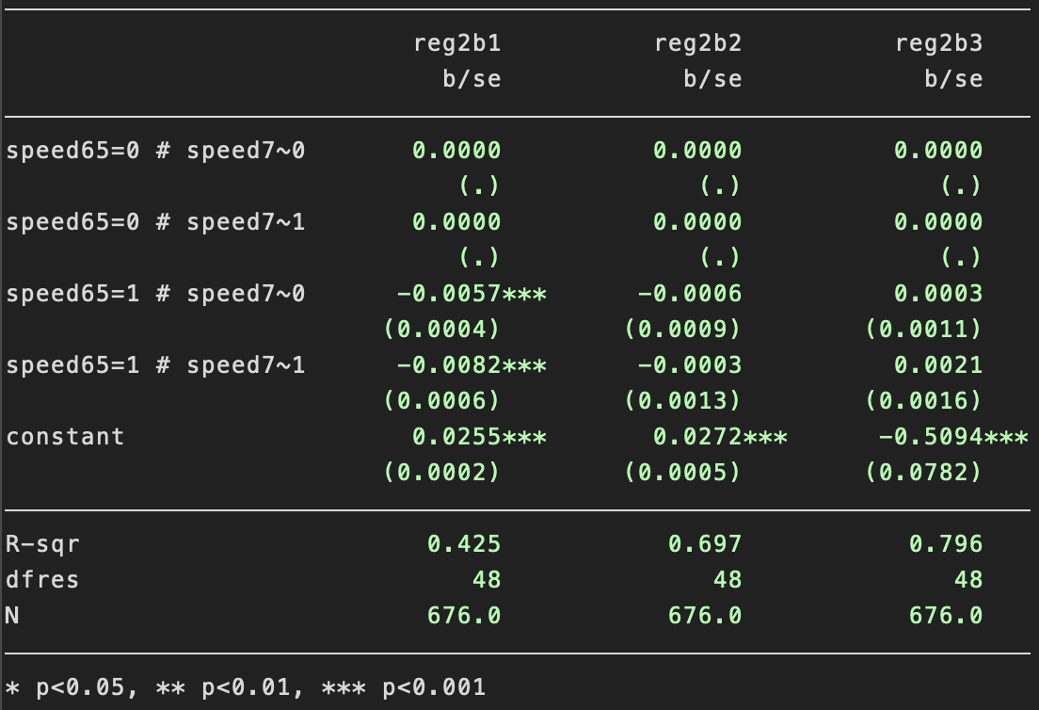

Table 9:

